Pharmacokinetic Distribution Profile of Castela Quassinoids
The distribution phase of the 24 identified quassinoids was characterized by evaluating the Volume of Distribution at steady state (V_{Dss}), Plasma Protein Binding (PPB), and Blood-Brain Barrier (BBB) permeability. The library exhibited a moderate global distribution profile, with V_{Dss} values clustering around a mean of 0.53 L/kg. While the majority of the compounds showed limited tissue sequestration, a notable outlier (Compound 5) displayed a significantly higher V_{Dss} of 1.28 L/kg, suggesting extensive extravascular distribution.
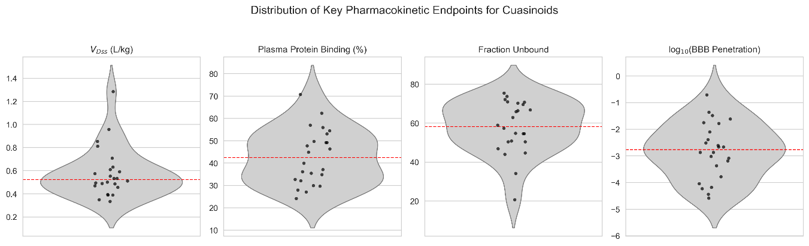
Analysis of plasma binding revealed a favorable profile for systemic bioavailability, with a mean Fraction Unbound (f_{u}) of approximately 58%. This relatively high proportion of free drug in the systemic circulation is inversely correlated with the observed PPB percentages, which averaged 42.4%. Furthermore, the log₁₀ transformed BBB penetration data indicated that the library possesses generally low central nervous system (CNS) exposure, centered at a value of -2.8, although a distinct sub-population exhibited higher permeability gradients. These combined metrics suggest that Castela quassinoids are primarily distributed within the plasma and extracellular fluid with minimal CNS liability, supporting their potential as systemic therapeutic leads.
Figure 1. Distribution of key pharmacokinetic endpoints for the 24 quassinoids.

Inter-variable Correlation and Mechanistic Interdependence
To elucidate the relationships between the predicted ADMET parameters, a hierarchical clustered heatmap was generated (Figure 2). A profound negative correlation (r = -0.98$) was observed between Plasma Protein Binding (PPB) and the Fraction Unbound (fu), confirming the internal consistency of the in silico model across the Castela library. Notably, a strong positive correlation cluster emerged between the inhibition of BCRP and OATP1B3 (r = 0.84$), suggesting that quassinoid scaffolds within this genus may act as multi-specific ligands for hepatic uptake and efflux transporters.
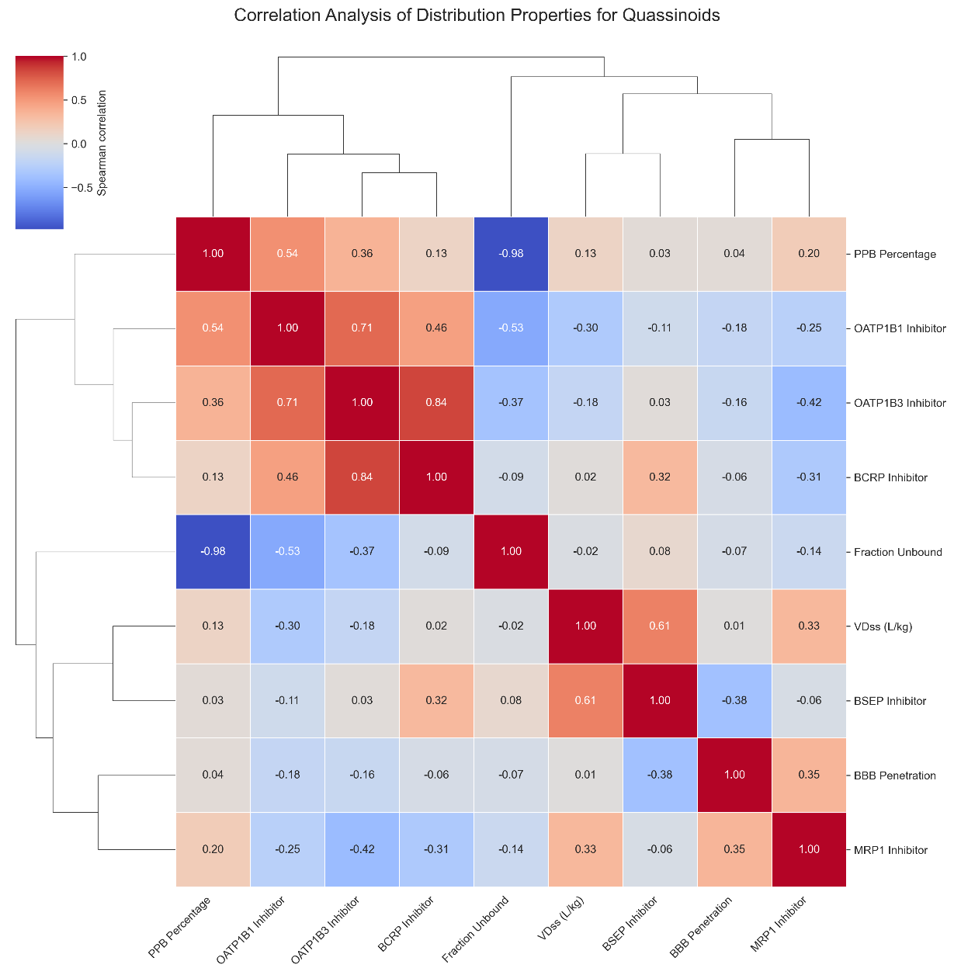
Furthermore, BSEP inhibition showed a moderate correlation with V_{Dss} (r = 0.61$), indicating that compounds with higher tissue distribution might also present a higher risk for cholestatic liability. Conversely, BBB penetration showed negligible correlation with global distribution markers V_{Dss} and fu implying that the ability of these quassinoids to cross the blood-brain barrier is likely governed by specific structural features or molecular weight rather than non-specific lipophilicity.
Figure 2. Correlation Analysis of Distribution and Transporter Properties for Quassinoids. The heatmap displays Spearman correlation coefficients between predicted ADMET parameters for the 24 Castela quassinoids. The color scale ranges from blue (strong negative correlation) to red (strong positive correlation). Hierarchical clustering on both axes identifies functional groupings, highlighting the inverse relationship between PPB and $f_u$, and the co-inhibitory potential between BCRP and OATP1B3 transporters.

Multivariate Analysis of Distribution Properties
To further explore the interplay between tissue distribution and systemic binding, a multivariate analysis was performed by plotting the Volume of Distribution at steady state (V_{Dss}) against Plasma Protein Binding (PPB) percentage. The resulting scatter profile (Figure 3) revealed a lack of significant linear correlation between these two critical parameters, as evidenced by a Spearman rank correlation coefficient of 0.13 (p = 0.55). This statistical independence suggests that for this specific library of 24 quassinoids, tissue sequestration is not primarily governed by the degree of protein binding in the plasma, but likely by specific structural affinities or active transport mechanisms.
The distribution profile reveals four distinct pharmacokinetic clusters:
- Systemic Retention: Most quassinoids cluster in the lower-left quadrant (V_{Dss} < 0.6 L/kg; PPB 25–55%), suggesting localization primarily within the extracellular fluid.
- High Tissue Affinity: Two compounds demonstrate superior distribution (V_{Dss} > 0.8 L/kg), with the primary lead reaching approximately 1.28 L/kg.
- CNS Penetration Potential: The highest V_{Dss} lead also exhibits peak log₁₀ (BBB Penetration) (0.8, yellow point), identifying it as a candidate for CNS-targeted research.
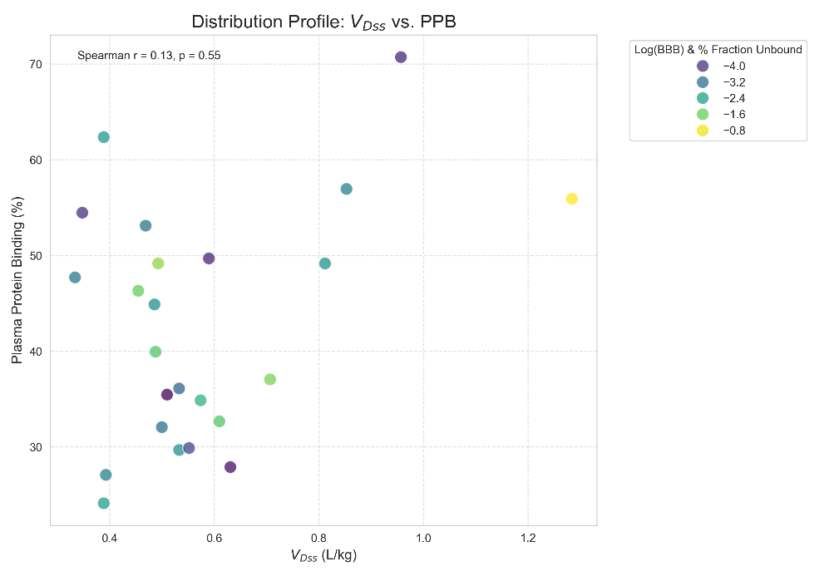
- Bioavailability Advantage: Large bubble sizes (f_{u}) among high-distribution leads indicate significant free drug availability for extravascular target engagement.
Figure 3. Multivariate distribution profile of Castela quassinoids. The scatter plot correlates Volume of Distribution (V_{Dss}) with Plasma Protein Binding (PPB%). Data point color represents the log₁₀ (BBB Penetration) gradient, while point size indicates the percentage of Fraction Unbound (f_{u}). Statistical independence (Spearman r = 0.13$) suggests that distribution is driven by specific structural properties rather than non-specific protein binding.

